aaaaaaaa

Internal Assessment Resource
Construction and Mechanical Technologies Level 1
EXPIRED
This resource supports assessment against:
Achievement Standard 91057 version 3
Implement basic procedures using resistant materials to make a specified product
Resource title: Making Life Less Dirty, Dull, Difficult, or Dangerous
6 credits
This resource:
- Clarifies the requirements of the standard
- Supports good assessment practice
- Should be subjected to the school’s usual assessment quality assurance process
- Should be modified to make the context relevant to students in their school environment and ensure that submitted evidence is authentic

Date version published by Ministry of Education | February 2015 Version 3  To support internal assessment from 2015
Quality assurance status | These materials have been quality assured by NZQA.  NZQA Approved number A-A-02-2015-91057-02-4616
Authenticity of evidence | Teachers must manage authenticity for any assessment from a public source, because students may have access to the assessment schedule or student exemplar material.  Using this assessment resource without modification may mean that students’ work is not authentic. The teacher may need to change figures, measurements or data sources or set a different context or topic to be investigated or a different text to read or perform.

Internal Assessment Resource
Achievement Standard Construction and Mechanical Technologies 91057: Implement basic procedures using resistant materials to make a specified product
Resource reference: Construction and Mechanical Technologies 1.20 v3 Mechanism
Resource title: Making Life Less Dirty, Dull, Difficult, or Dangerous
Credits: 6
Teacher guidelines
The following guidelines are supplied to enable teachers to carry out valid and consistent assessment using this internal assessment resource.
Teachers need to be very familiar with the outcome being assessed by Achievement Standard Construction and Mechanical Technologies 91057. The achievement criteria and the explanatory notes contain information, definitions, and requirements that are crucial when interpreting the standard and assessing students against it.
Context/setting
This activity requires students to skilfully and efficiently implement basic procedures using resistant materials to make a specified product (a mechanism). Like all machines, this mechanism will be designed to meet an identified need or opportunity – that is, to make life “less dirty, dull, difficult, or dangerous”.
Two approaches are possible when using this standard for assessment.
- The teacher provides several options for a mechanism and then, in discussion with the class, selects an appropriate mechanism for all students in the class to make and/or allows individual students to negotiate a variation of the selected outcome. (An example of an appropriate kind of mechanism, with its specifications, is given in Student Resource A: Ram cylinder assembly and specifications.)
The teacher provides a plan for making the selected mechanism, including:
- drawings (for example, sketches with measurements taking into account tolerances for the ram cylinder assembly)
- step-by-step instructions on how to construct the mechanism (which must include the range of techniques set out in the standard)
- a cutting list
- a materials list
- a set of specifications, which the completed mechanism must meet.
- The students work individually to make their mechanism, applying techniques that comply with health and safety regulations and carrying out tests to ensure that their implementation of all techniques meets accepted standards.
The students have been engaged in technological practice and are now at the point where they have fully established the specifications for their own mechanism and are ready to make it. They can provide their own plan for making their mechanism, which includes all the items listed above (in the plan for the first approach).
In either case, the students:
- make their mechanism, using the range of techniques described in the standard (see also Student Resource B: The range of techniques)
- keep evidence of their construction work, their testing, and their responses to issues identified by testing (for example, they could keep a brief log alongside the step-by-step instructions and/or take photographs to record the tests they have carried out and their results).
In either case, ensure that:
- the materials and techniques that the students plan to use provide sufficient scope for them to meet the requirements of the standard
- there is an agreed step-by-step plan that provides a sound and robust process for making the mechanism
- you conference with the students and support them as they make their mechanisms (for example, by advising them about events that may occur within the machinery and about tools that they may want to use in addition to those that they should be able to use independently, as part of the assessed task)
- the students are given guidance on the testing procedures that they will need to apply to ensure that the mechanism is constructed accurately and meets specifications. (For example, see the model in Student Resource C: Testing checklist. Such a checklist can provide a basis for teacher–student discussions about how the mechanism will be tested, and how problems can be addressed, at all stages of construction.)
Whenever you provide support during the assessment activity, notice whether the support is for tasks the student should be able to do independently or for additional tasks that are not part of the achievement standard, and make this distinction when assessing the student's work.
Prior learning
Ensure that all students have the necessary prior learning. Encourage them to practise the relevant skills and techniques before beginning this activity.
Conditions
This is an individual assessment task. It is recommended that students be given 15 weeks (60 hours) of in-class time to complete it.
Because you are required to assess the ways in which students make their mechanisms (that is, the techniques and tests they use and the manner in which they use them) as well as assessing the final product, the students should complete all practical work in class.
Resource requirements
An appropriate work environment, such as an engineering workshop, that includes the tools and materials that the students need in order to work safely to make the mechanism, for example:
- a centre lathe with one fixed “steady”
- a PVC solid rod pipe and O rings to match the PVC pipe
- bathroom scales, to model a testing situation.
Models of work that meets the standard, such as:
- the examples shown in Student Resource D: Models of planning and sketching, and in Student Resource E: Photographs of some appropriate mechanisms
- a completed example of a fully functioning mechanism
Access to a camera, so that students can take and annotate photographs to use as evidence if they wish to.

Additional information
This standard requires you to make judgements about the ways in which techniques are implemented, as well as about the quality of the finished product. For example, you are required to judge (for Merit) whether the student has shown “independence and accuracy in the execution of the techniques and tests” and (for Excellence) whether the student has worked “in a manner that economises time, effort, and materials”.
Measures
Independence relates to the student’s manner of working. Specifically, do they make the agreed product with minimal advice and guidance from their teacher and without relying on help from fellow students? (Evidence: classroom observation.) For more on this measure, see below.
Accuracy of execution is one of the main ways in which skill (the criterion for Merit and Excellence) can be recognised. (Evidence: finished product.)
Economy of time relates to personal organisation. Do students look after their resources between periods so that they can quickly pick up where they left off? Do they spend time wandering and chatting to classmates? Do they find something to go on with if the machine they need is in use or out of order? Do they think before they act and so avoid time-consuming undoing and redoing? (Evidence: classroom observation.)
Economy of effort is about working efficiently. It is a function of knowledge, thinking, planning, and skill. Does the student know what to do and get on and do it, or do they rely on trial and error? Do they use data from testing to guide next practice? Do they use the correct tool for the task? (Evidence: students’ dated log entries or annotations; classroom observation.)
Economy of resources is about minimising the use of materials. (Evidence: students’ photos; classroom observation.)
Economy of time, effort, and resources are often linked. For example, choosing the correct tool will save time and effort and minimise wastage.
Recording of evidence
As teacher, you need to be able to demonstrate that your judgements are soundly based. This means some recording of evidence is necessary.
Recording of evidence should not, however, be time-consuming or onerous. Students could be asked simply to keep a record of progress and how they have resolved problems – maybe by annotating construction plans or the equivalent. You could add your own observations to the students’ records.
Students could also provide evidence by:
- establishing a schedule of tests (that is, what tests will be done, and when) and recording the outcomes of the tests as they apply them
- taking and annotating photos to show economic use of materials (for example, by photographing layout) and accuracy.
By asking your students to record evidence, you reinforce that their manner of working is also assessed in this standard.
Ensure that all students have the opportunity to explain clearly why they did what they did.
Independence
Ensure that all students know what “make with independence” looks like (the notes on “make” are for your guidance only).
Achieved – make (with some guidance)
“With some guidance” means the teacher (or peers) may:
- respond to student-initiated requests for assistance, for example, where to find suitable material, or what tool to use
- sometimes prompt the student to, for example, consider other options, think about the wisdom of a choice, or reread the brief.
The teacher (or peers) may NOT, however:
- make any decisions for students
- assist a student in any hands-on way (do any part of the project for them)
- respond to frequent questions or requests for step-by-step guidance.
Merit – make “with independence and accuracy”
“With independence” means the student:
- owns the practice (acts as if responsibility for achieving a quality outcome sits with them)
- plans effectively, thinks ahead, is well-organised, self-starting and self-managing
- does their own decision-making
- books any equipment/machines they need in timely fashion
- purchases and/or brings required materials in timely fashion
- stores their work carefully so that it is easily retrieved next period
- carries out appropriate checking and testing and takes required corrective action
- recognises and deals with issues promptly, so that they are able to meet the deadline
- is always able to describe what they are doing, why, and where their project is up to.
It does NOT mean that the student:
- is unable to ask for help with technical or safety issues (for example, faulty equipment).
Excellence – make “with independence and accuracy”
There is no step-up on “independence and accuracy” for Excellence – see Merit.
Internal Assessment Resource
Achievement Standard Construction and Mechanical Technologies 91057: Implement basic procedures using resistant materials to make a specified product
Resource reference: Construction and Mechanical Technologies 1.20 v3 Mechanism
Resource title: Making Life Less Dirty, Dull, Difficult, or Dangerous
Credits: 6
Achievement | Achievement with Merit | Achievement with Excellence
Implement basic procedures using resistant materials to make a specified product. | Skilfully implement basic procedures using resistant materials to make a specified product. | Efficiently implement basic procedures using resistant materials to make a specified product.
Student instructions
Introduction
For this assessment, you will make a specified product (a mechanism) using resistant materials and implementing basic procedures. In making the mechanism, you will keep to the specifications and follow a step-by-step plan. These may be provided by your teacher or you may develop them independently and have them confirmed by your teacher.
Teacher note: You could select the mechanism, or a range of mechanisms, alone or in consultation with the class. If the mechanism is teacher-selected, students could be given the opportunity to negotiate a variation.
The kind of mechanism used as the example in this resource is described in Student Resource A: A ram cylinder assembly and specifications.
Your finished product will comprise:
- the mechanism that you have constructed
- a portfolio that includes photographs of the finished mechanism and evidence of the techniques and testing procedures you used during construction.
You will be assessed on:
- the extent to which your mechanism meets the specifications
- the manner in which you follow the plan and apply techniques and testing procedures that comply with relevant health and safety regulations. Your independence, accuracy, and efficiency will be taken into account.
This is an individual task. You have 15 weeks (60 hours) to complete it.
Teacher note: Adapt the time allowed to meet the needs of your students.
Preparatory activities
To prepare for this assessment task:
- Consider the purpose of the mechanism you are going to make. How will it make life less dirty, dull, difficult, or dangerous? Keep this purpose in mind as you plan for and work on your mechanism.
- If your teacher has provided a step-by-step plan, read it carefully. If not, write or review your own step-by-step plan for constructing your mechanism. Familiarise yourself with each step in the process.
- Familiarise yourself with the techniques you will use to make your mechanism. Refer to Student Resource B for the range of techniques that must be included.
- Ensure that you know how to apply these techniques so that you comply with relevant health and safety regulations.
- Refer to the testing checklist in Student Resource C and adapt it if necessary (for example, if you are making an alternative kind of mechanism). Check that the plan tells you at which step you will need to apply each of the tests for your mechanism. Discuss this with your teacher if necessary.
- Collect the materials required to make your mechanism.
Check with your teacher that the step-by-step plan you will follow, the techniques you will use, the testing you will carry out, and the materials you will use are suitable for you as a Level 1 student and for the mechanism you are making. (This will help to ensure that you have access to all grades of achievement.)
Practice the techniques you will use to make and test your mechanism until you can apply them efficiently and confidently.
Task
Make your mechanism to meet the specifications, following the step-by-step instructions in the agreed plan.
As you make your mechanism, develop a portfolio that contains a record of what you do, including all testing (this evidence could include annotated photographs and a completed testing checklist).
When you have finished, photograph your mechanism.
Hand in:
- the mechanism that you have constructed
- a portfolio that includes photographs of the finished mechanism, written comments, and/or other evidence of the techniques and the testing procedures you used during construction.
Student Resource A: Ram cylinder assembly and specifications
The mechanism used as the model in this resource is a ram cylinder assembly, water-and/or air-operated, made from PVC tubing, piping, and solid, using 4 mm drip irrigation fittings and plumbing equipment (see Student Resource D for examples of planning and sketching that relate to this model).
For example, it could be a mechanism for a chip-maker, a TV swivel, or a deck-chair adjuster, or it could be for a remote window opener, wheelie-bin lid opener, gate opener, or glasshouse window opener. (See Student Resource E for photographs of some of these mechanisms.)
The specifications for the completed mechanism are functions for its intended purpose.
Teacher note: Specifications are short statements that describe the function of the finished product. They should not describe a particular skill or efficiency. At all grade levels the product is required to meet specifications. Skilful and efficient implementation is not required at the achieved level.

Student Resource B: The range of techniques
The following range of techniques must be included in the instructions:
- one or more of measuring/marking:
- marking out using engineers’ ink/a scribe/oddleg callipers
- measuring – calibrating the lathe, measuring for fit (an interference fit should be 0.1 mm per 20 mm, and a running fit should be 0.1 mm per 20 mm)
- one or more of sizing/shaping/forming:
- sizing, e.g. facing off using a fixed steady
- shaping, e.g. cutting an “O” ring groove to the correct size
- one or more of joining/assembling:
- joining, e.g. joining end cap to cylinder (interference fit), joining piston to piston and to end cap (interference joint), joining piston to cylinder (running fit)
- one or more of finishing/detailing:
- finishing, e.g. using appropriate techniques to enhance the quality of machined surfaces.
Student Resource C: Testing checklist
Part | What | Why | Evidence  E.g. photo, written record, completed test document
End caps | Interference fit to cylinder | To ensure correct hold | E.g. photograph of me measuring, or comment – measured correctly
Piston | Groove depth and width meets specifications (see spec. sheet) | To ensure correct function of ring | E.g. photograph, or comment – checked fit of ring and measurement using vernier callipers
Piston | Quality of surface finish to be smooth | To ensure correct and smooth movement and O seal | E.g. close-up photograph of surface quality, or comment – checked quality
Piston | Shaping of O ring groove –i.e. parallel sides and flat bottom | To ensure O ring functions correctly and seals | E.g. photograph, or comment – checked shaping
Piston to piston shaft | Interference fit | To create a join which will hold together under operational conditions | E.g. photograph of the parts joined being held together firmly or of vernier callipers being used and close-up measurement reading of the same
Piston to cylinder | Running fit | To ensure ease of movement up and down the cylinder | E.g. photograph of measuring with vernier callipers and photograph showing how it slides
Finished assembly | Airtight seal through quality machining  (submerge in water and fill with air … leaks will produce bubbles) | To ensure correct function and no leaking | E.g. comment on whether seal leaks in testing – No bubbles/Some bubbles, indicating a leak, which I used a sealant to remedy

Student Resource D: Models of planning and sketching

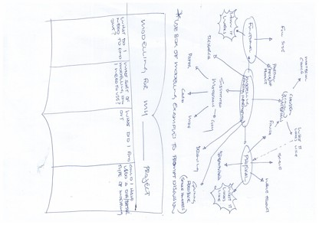

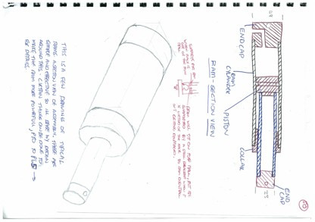

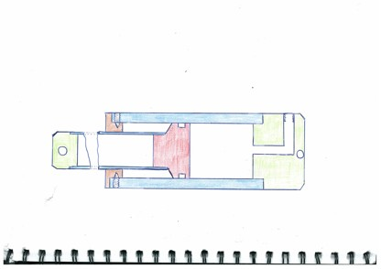
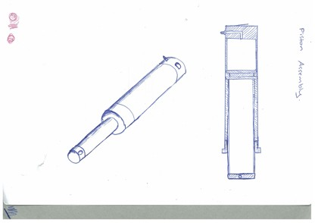

Student Resource E: Photographs of some appropriate mechanisms
1. A nifty way to connect valves in tandem
- allowing for “power”, “exhaust”, and “hold” functions
- pruning device, air operated
- tandem valve assembly using 4 mm dripper valves
- integral ram cylinder and pruning shears (secateurs)

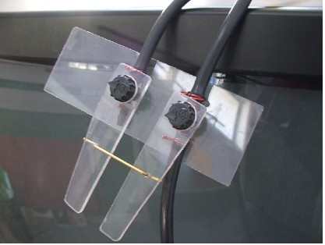

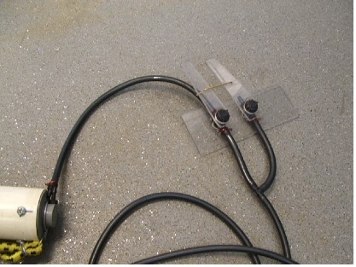
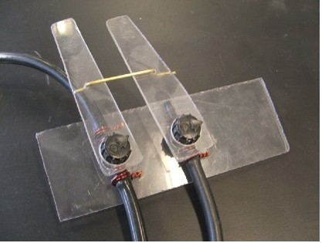
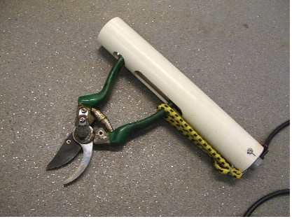
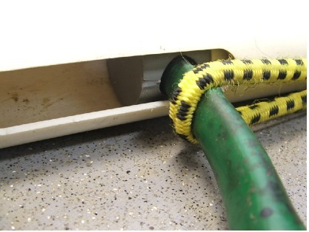
2. Spud chipper
Safety yet to be considered, 400 newtons of force (which is enough to lift a 40 kg load), due to our mains water pressure.

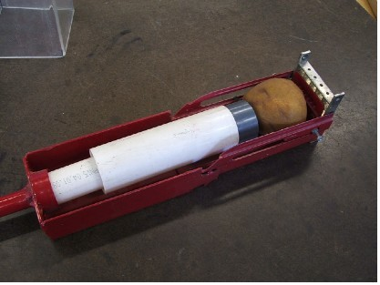

Water source connection to garden tap

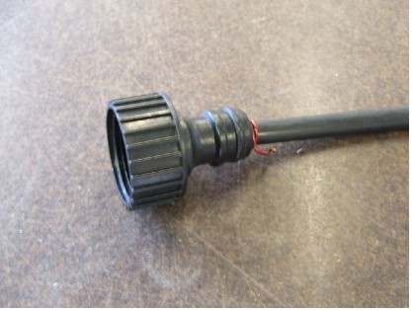

The output end

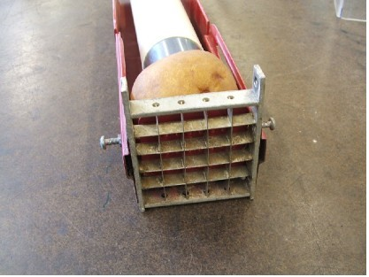

Piston assembly

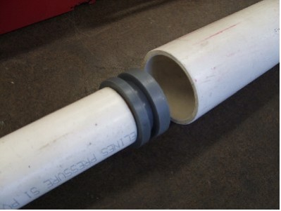
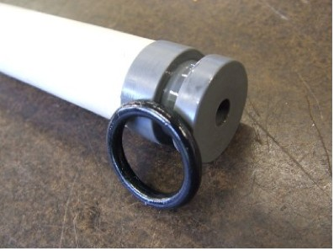
3. Air-operated TV twister, bike-pump operated




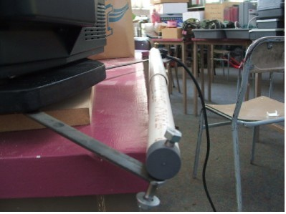
Assessment schedule: Construction and Mechanical Technologies 91057 Mechanism Making Life Less Dirty, Dull, Difficult, or Dangerous
Evidence/Judgements for Achievement | Evidence/Judgements for Achievement with Merit | Evidence/Judgements for Achievement with Excellence
With some guidance, the student has followed a set of techniques to make a mechanism that meets specifications.  For example:  The student has created the mechanism using one or more techniques from each of the following categories:  - measuring/marking out  - sizing/shaping/forming  - joining/assembling  - finishing/detailing/tuning.  The mechanism functions according to the specifications, but the student may need further direction to debug, for example, for a leak or other fault.  The student needed a little prompting about measuring accurately, tool selection, lathe speed, and sizes to match designs or drawings.  The student was able to follow the design details in the drawings to guide the machining. They machined the pieces, but not all the pieces show precision and accuracy as defined in the instructions. Some rescuing was required, for example, an interference fit was replaced with a glue fit.  They have undertaken a range of appropriate tests to demonstrate that the final mechanism meets specifications.  For example:  The student has checked the interference fit of the end cap to the cylinder to ensure correct hold.  The student needed prompting to ensure that they covered a range of tests. They sometimes responded to a test with subsequent appropriate actions to debug.  The student has not always responded appropriately to comparative visual checks (through use of measuring tools) and visual checks on surface quality.  They have applied techniques to comply with relevant health and safety regulations.  The student has followed classroom rules such as:  - ensure sleeves rolled up when using any machines  - wear safety glasses when machining  - ensure all machine guards are fitted and working before commencing machining  - ensure machine is turned off before using any measuring instruments.  This description relates to only part of what is required, and is indicative only. | The student has shown independence and accuracy in the execution of the techniques and tests.  For example:  The student read the drawings and followed the instructions independently. They measured out and marked out the mechanism accurately, as described in the drawing specs, using the appropriate techniques.  The student used joining skilfully. They accurately completed all machining of components to the tolerances outlined in the plan (e.g. machined the surface to a quality that ensured an airtight seal). The student visually checked the machined measurements and surface quality against the accepted standard to reach this level of accuracy.  The student applied techniques to comply with relevant health and safety regulations.  This description relates to only part of what is required, and is indicative only. | The student has independently and accurately undertaken techniques and tests in a manner that economises time, effort and materials.  For example:  The student has followed the step-by-step instructions independently and accurately to make the specified mechanism and finished in a timely manner.  The student cut all of the component pieces to the lengths outlined in the design specs, which allowed for a cutting tolerance but did not waste the PVC – the parts were parted off (on the lathe) after machining. All relevant marking out was completed accurately (according to design specs) and in an ordered manner (not using trial and error). The student’s machining of the components of the mechanism showed accuracy and precision in the use of the lathe, with minimal repeats of techniques.  As each technique was implemented, the student applied the relevant test. They responded appropriately to the results of all tests. The mechanism components met the required standard.  The mechanism works as expected in all situations outlined in the plan-specifications.  The student used only the amount of material outlined in the plan.  The student applied techniques to comply with relevant health and safety regulations  This description relates to only part of what is required, and is indicative only.
Final grades will be decided using professional judgement based on a holistic examination of the evidence provided against the criteria in the Achievement Standard.

